## Lesson 30 – Activity Sheet

## Getting Started

Lesson 17 covered the use of the micro:bit **pins** and how to wire up a simply alarm system. This activity opens up the use of all of the pins through the use of the Kitronik **Edge Connector**.

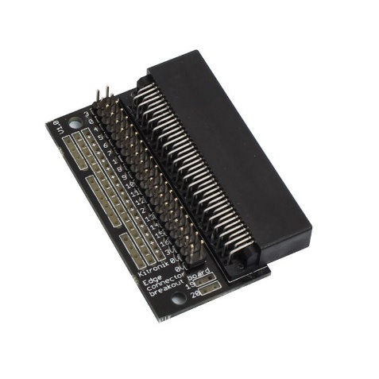This add on board allows access to every pin by connecting **jumper wires**, whilst keeping the other pins free to control other actions or to use as additional inputs and outputs. This will be useful in the final micro:pet project.

Take your micro:bit and connect it to the edge connector, slot it into place in the gap provided.

**The micro:bit Zoo**

In this activity you will connect four wires. Hold the ground (GND) wire and then touch one of the other wires, an image of an animal will be displayed on the LEDs. Touch a different wire and a different picture of an animal is displayed.

* Take four male to female jumper wires and attach the female end to Pin 0, Pin 1, Pin 2and the GNDpin which is indicated by the 0v sign.
* Each of the pins is label on the edge connector, however on the front row of pins, from the left, Pin 0 is the 2nd pin from the left, Pin 1 is the 7th, Pin 2 is the 13th and the GND pin is the final pin on the right.

**The micro:bit Zoo program**

Copy up the program code below. This uses a while loop to continually check if you have touched one of the wires. If you have then, depending on which wire, an image is displayed on the LEDs. If you do not touch any wires then the image of a skull is displayed.

from microbit import *

import time

while True:

if pin0.is_touched():

display.show(Image.DUCK)

sleep(10)

elif pin1.is_touched():

display.show(Image.COW)

sleep(10)

elif pin2.is_touched():

display.show(Image.BUTTERFLY)

sleep(10)

else:

display.show(Image.SKULL)

sleep(1)

Download the program to your micro:bit and hold the GND wire in you right hand between your finger and thumb. Then use the finger of your **left** hand, touch one of the other wires. This creates a **circuit** which then triggers the pinx.is_touched() code to run and display the related image.

See how many learners you can connect in a chain and trigger the program to display and image. All hold hands and the first student holds the GND wire and the last students touches one of the other wires.

* Edit the code and change the images that are displayed
* Wire up another pin, try out Pin 3, adjust the program code
* Replace the images with scrolling text

**Add Tin Foil to the Ends of the Wires**

Now that you have a working program you can add **conductive materials** to the ends of the wires. Now instead of having to touch the wires together you can simply touch the conductive materials. In this way, you are making a simple button. This technique will be useful when you make your final project. You can add lots of interactivity to the project by touching various parts of the model.

Now you can touch the tin foil on the GND wire and then touch another piece of tin foil and trigger the image to be displayed.

## Success Criteria

* Set up one pin to display an image when touched
* Set up three pins to display a range of images when touched
* Use tin foil to create simple buttons for the program
* Edit the program and add your own images or text

Pro-tip

Tin foil is not the only conductive material that you can use. How about trying out: playdough, metal, fruit, copper wire, metal buttons. Basically, any object that is conductive can be used instead of tin foil.

## Test Time

When running the program ensure that the wires are securely connected to the pin and that you are touching the material. This will ensure that you make a good contact and create a circuit.

## Stretch Tasks

## **micro:bit Piano**

Now you are ready to build a micro:bit Piano. This adapts the previous program to play musical notes when the foil is pressed. Although you could use other conductive materials.

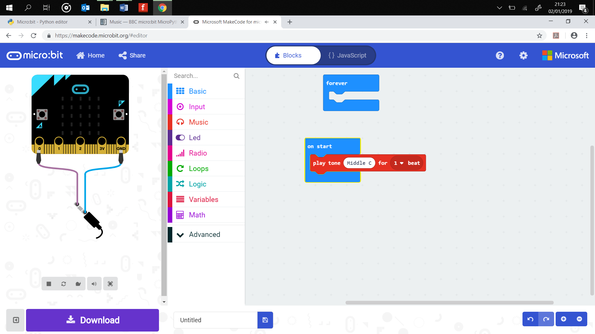First wire up the headphones or speaker so that you can hear the musical notes, then copy the program code.

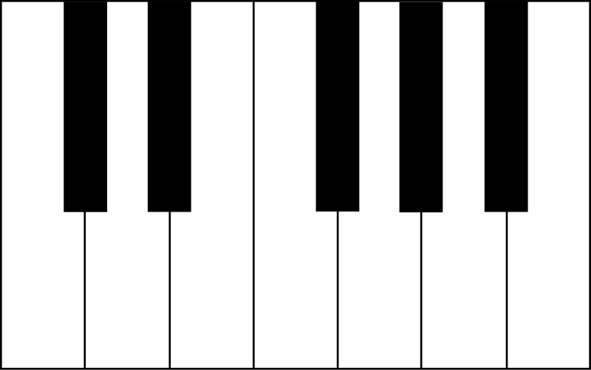You could cut strips of foil to make piano keys. Line them up in the order of the notes found on a keyboard and then play a little tune!

from microbit import *

import time

import music

while True:

if pin0.is_touched():

tune = ["A2:4"]

music.play(tune)

sleep(4)

elif pin1.is_touched():

tune = ["B2:4"]

music.play(tune)

sleep(4)

elif pin2.is_touched():

tune = ["C2:4"]

music.play(tune)

sleep(4)

else:

display.show(Image.SKULL)

sleep(1)

* Each note is expressed as a string of characters, NOTE[octave][:duration], For example, C4:2 refers to the note C in octave number 4 to be played for a duration of 2. The square brackets around each Note and duration show that it is a list data structure. A list contains a number of items under a single identifier name.
* Add all seven notes of the musical scale, A, B, C, D, E, F, and G
* Practice a song, tune or melody and perform it for your class or teacher

## Final Thoughts

Think about how you could use this program outside in the final project to trigger user interactions and responses. Remember there are many materials other than foil that conduct and could be used to make a circuit.